NAME : ANANTHAKUMAR S

R.NO : 737819ECR010

EMAIL :ananthakumar26065@gmail.com

COLLEGE :KONGU ENGINEERING COLLEGE

DATE :12/09/2022

**Module 3 Python Assignment**

**Questions**

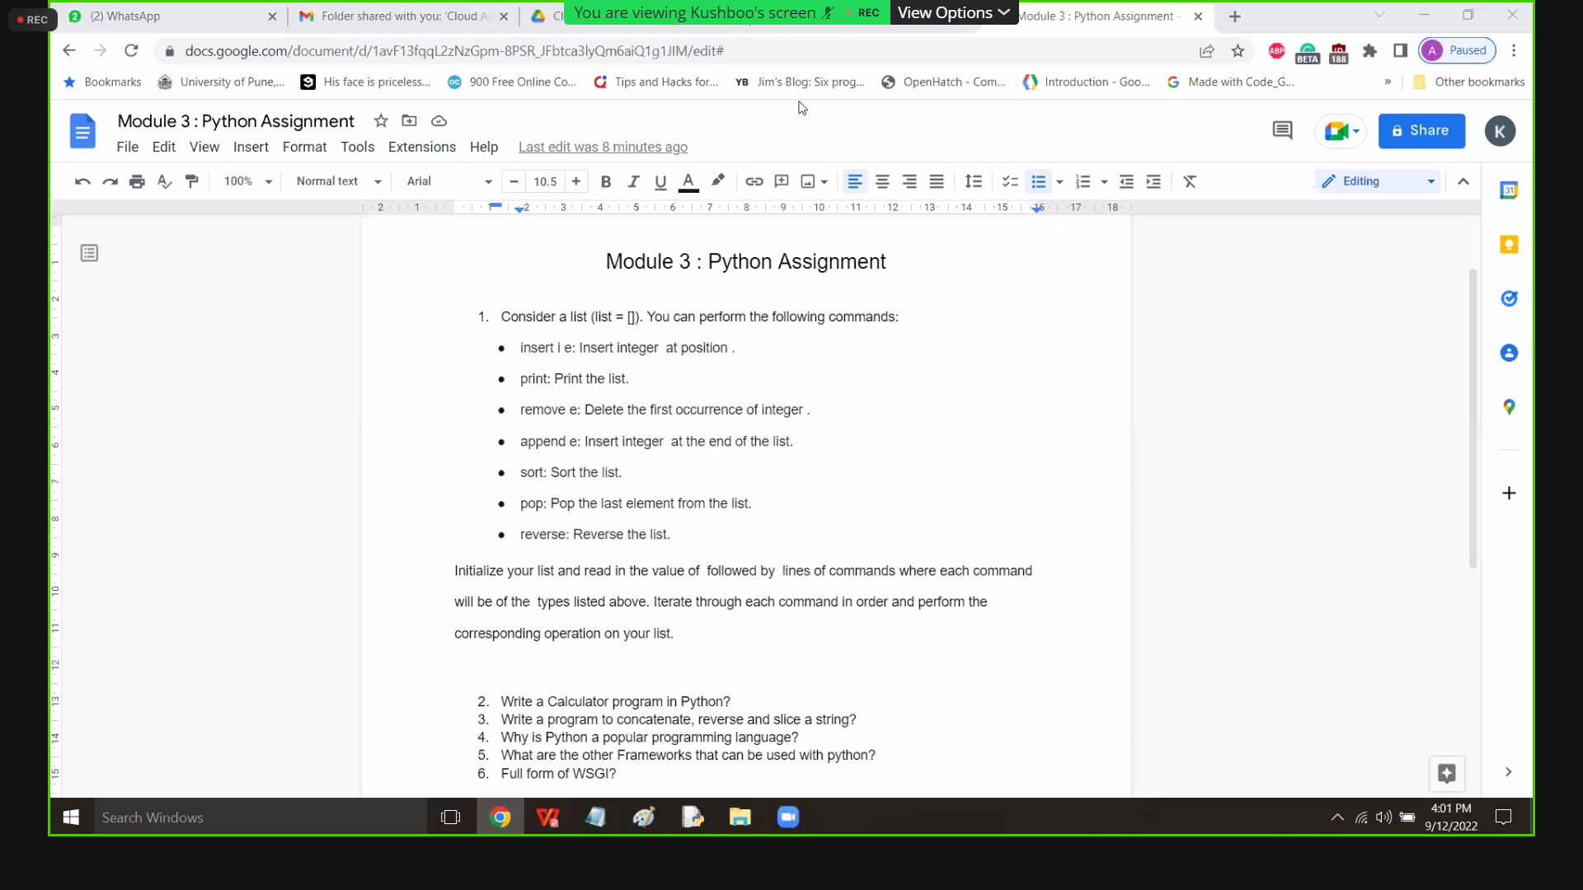

**Answers**

**1.Perform the following commands in a list**

**Code:**

lst = [1,2,3,4,5]

print('List Initially: ',lst)

#inserting an element 33 at position 2

lst.insert(2,33)

#priinting the list

print('List after inserting 33 at position 2: ',lst)

# adding the element

lst.append(6)

print('List after appending 6 at the end: ',lst)

#sorting the elements

lst.sort()

print('List after sorting: ',lst)

#pop a element

removed_element = lst.pop(2)

print('Removed Element: ', removed_element)

print('List after poping: ', lst)

#reverse a element

lst.reverse()

print('List after reversing: ',lst)

**Output:**

List Initially: [1, 2, 3, 4, 5]

List after inserting 33 at position 2: [1, 2, 33, 3, 4, 5]

List after appending 6 at the end: [1, 2, 33, 3, 4, 5, 6]

List after sorting: [1, 2, 3, 4, 5, 6, 33]

Removed Element: 3

List after poping: [1, 2, 4, 5, 6, 33]

List after reversing: [33, 6, 5, 4, 2, 1]

**2. Write a Calculator program in python**

**Code:**

# This function adds two numbers  
def add(x, y):  
    return x + y  
  
# This function subtracts two numbers  
def subtract(x, y):  
    return x - y  
  
# This function multiplies two numbers  
def multiply(x, y):  
    return x * y  
  
# This function divides two numbers  
def divide(x, y):  
    return x / y  
  
  
print("Select operation.")  
print("1.Add")  
print("2.Subtract")  
print("3.Multiply")  
print("4.Divide")  
  
while True:  
    # take input from the user  
    choice = input("Enter choice(1/2/3/4): ")  
  
    # check if choice is one of the four options  
    if choice in ('1', '2', '3', '4'):  
        num1 = float(input("Enter first number: "))  
        num2 = float(input("Enter second number: "))  
  
        if choice == '1':  
            print(num1, "+", num2, "=", add(num1, num2))  
  
        elif choice == '2':  
            print(num1, "-", num2, "=", subtract(num1, num2))  
  
        elif choice == '3':  
            print(num1, "*", num2, "=", multiply(num1, num2))  
  
        elif choice == '4':  
            print(num1, "/", num2, "=", divide(num1, num2))  
         
        # check if user wants another calculation  
        # break the while loop if answer is no  
        next_calculation = input("Let's do next calculation? (yes/no): ")  
        if next_calculation == "no":  
          break  
     
    else:  
        print("Invalid Input")

**3. Write a program to concatenate,reverse and slice a string**

**Code:**

# string concatenation

x = "Python is "  
y = "Easy to learn"  
z =  x + y  
print(‘Concatenated string: ‘,z)  
  
  
#string reverse  
  
txt = "Hello World"[::-1]  
print(‘Reversed String: ’,txt)  
  
  
#string slicing  
  
s="IBM Python programming" # initial string

slicedString=s[0:10:1] # slicing

print (‘Sliced String: ‘,slicedString)

**Output:**

Concatenated string: Python is easy to learn

Reversed String: dlroW olleH

Sliced String: IBM Python

**4. Why is Python a popular programming language?**

Due to its ease of learning and usage, Python codes can easily be written and executed much faster than other available programming languages. And also due to the availability of its vast range of applications with in-built solutions to standard web development tasks, the speed of a single project increases by many times. Python is used in big data and machine learning research purposes to enhance development in those fields. Python is extremely useful in the AI domain and is also used in robotics and other tech advancements, besides data science. One of the main reasons why Python’s popularity has exponentially grown is due to its simplicity in syntax so that it could be easy to read and developed by amateur professionals as well.

**5. What are the other frameworks that can be used with python?**

The other frameworks that can be used with python are,

* Cubicweb
* AIOHTTP
* Dash
* Bottle
* Django
* CherryPy
* Falcon
* Giotto
* Growler

**6. Full form of WSGI**

The Web Server Gateway Interface is the full form of WSGI